**HOTEL MANAGEMENT DATABASE SYSTEM**

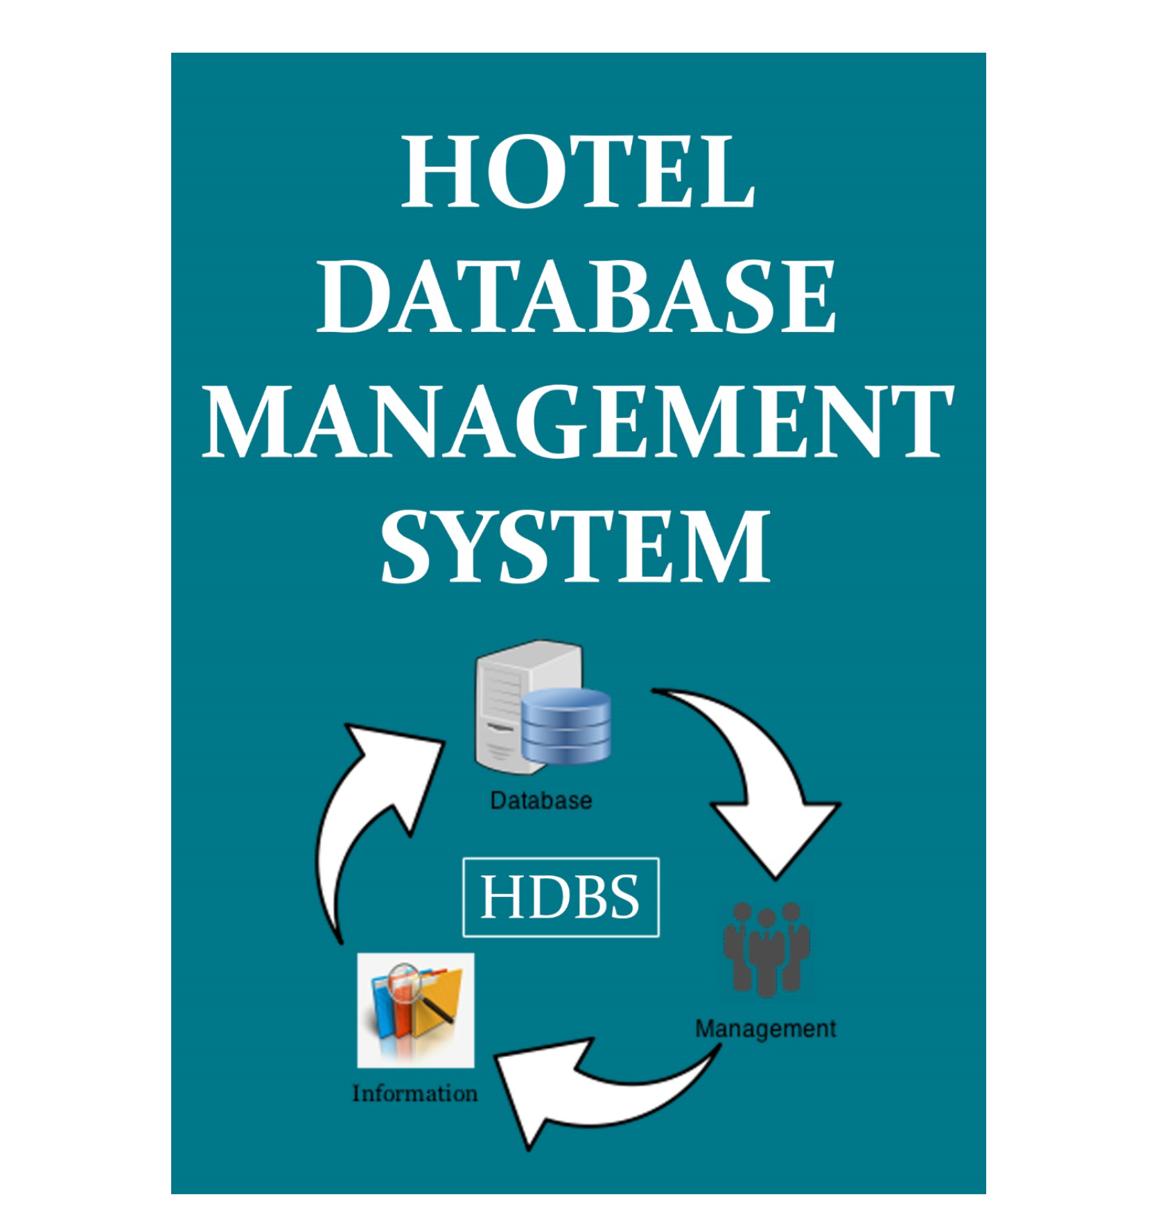

**INTRODUCTION**

There will be many operations taking place in the hotel and it requires many employees to take care of these organizations. The details of the employees and their salary related matter can also be stored in the database. Some hotels will be having the facility of the lodging services. So there will be many rooms available. These rooms will also belong to different categories. It can also be categorized based on the prices that each room will have. There should be employees who will have to manage the services that need to be provided to the customers. The rooms in the hotel can be booked online also. The payment can be done through the online mode as well as the cash payment. All the payment information can also be maintained in this database. The details of the customer like name, address, contact number, number of days of stay, his identity, check in check out time etc will be maintained in the hotel management system database. There will also be food that the customer requires will be provided in the hotels. The bill will be generated based on the orders made. The customers need to pay for it at the time of check out.

DATABASE DESIGNING